CSA1505 - CLOUD COMPUTING AND BIG DATA ANALYTICS
Experiment-2
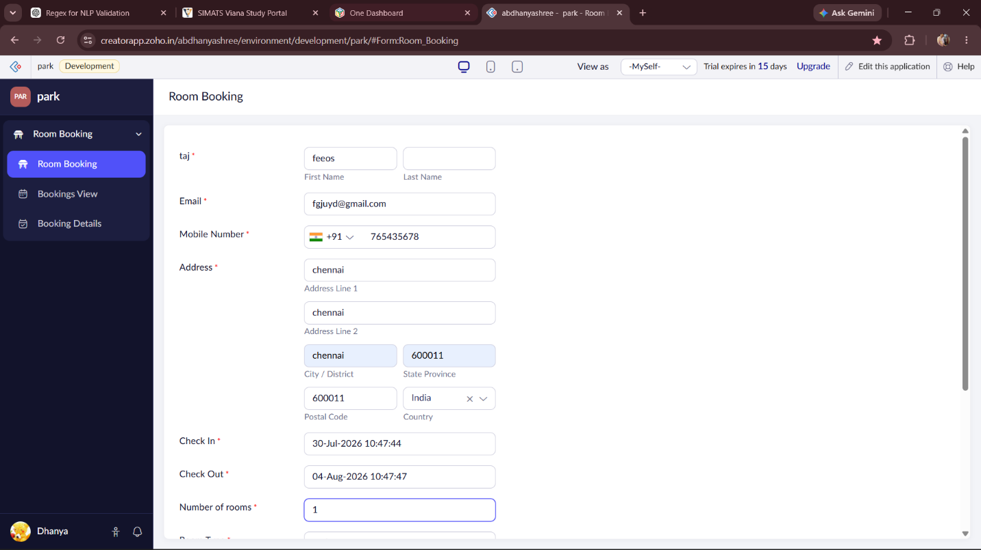
Create a simple cloud software application for room Booking Reservation System using any Cloud Service Provider to demonstrate SaaS include the necessary fields such as search for cabs, from, to, rental , out station, Package type, hours/Days etc. Input

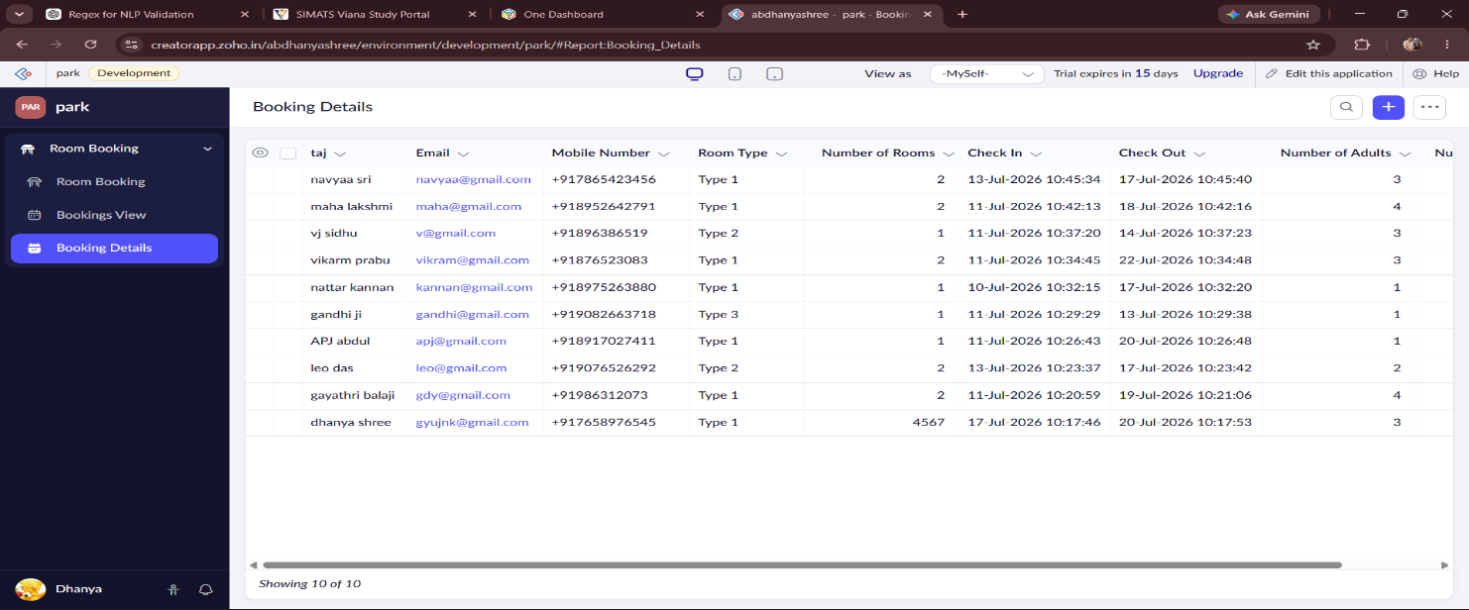
Output
Overview
